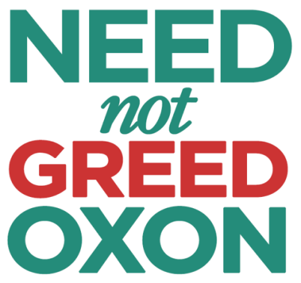
Planning for Real NEED not Speculator GREED in Oxfordshire

7th February, 2018

Dear Councillor,

The Housing and Growth Deal is not the right deal for Oxfordshire

In the near future, all District Councillors and County Council Cabinet Members will be asked to vote on the Government’s Housing and Growth Deal for Oxfordshire.

The Deal would commit our local authorities to providing 100,000 houses by 2031, a housebuilding level that is more than double the Government’s own projections of household growth for the County and still almost 50% above the Government’s own assessment of housing need after a large affordability allowance has been added, including several thousand houses over and above those already proposed in Local Plans. This is a significant commitment to make without a lot more careful thought and full public consultation.

NNGO suggests that you should oppose the existing Housing and Growth Deal. A better future is possible for Oxfordshire!

What is the funding for and is it enough?

The Deal promises £215million in return for this housing commitment. At this stage it is still not clear how the additional funding will be used. £60m for affordable property is welcome, but how precisely is this to be spent? Will ‘affordable’ houses be at 80% of market value, or will they be the social housing that is needed? Moreover, it isn’t even clear to us that this really is new, additional money.

The £150m for infrastructure is only £1,500 per new house. Exactly what projects will this pay for and where will they be? The recent Oxfordshire Infrastructure Strategy showed a large gap between needs and funding. We believe this level of funding is unlikely to cover the direct, hard infrastructure needs of the additional houses over and above Local Plan commitments. It will do nothing to alleviate the massive traffic problems that will result from the amount of housebuilding proposed. Nor will it do anything to meet existing needs or to cover ‘soft’ infrastructure such as health services.

We should not sell the future of Oxfordshire for so little!

What do we think is wrong with the Housing and Growth Deal?

Our main concerns go wider than just the funding though:

- As mentioned above, the purpose of the funding is not clearly explained and it seems insufficient given the scale of the gap identified by the Infrastructure Plan and the amount of growth that might eventually be planned.

- The draft agreement itself says that 100,000 houses is well above the Government’s own assessment of Oxfordshire’s need to 2031. Our need figure has been assessed as 68,000 houses, of which 48,000 is to meet projected household growth and a further 20,000 (30% of the total) has been added to reflect affordability concerns. So 20,000 of the 68,000 houses could help to reduce affordability problems – especially if they are focused on ‘need’ and not ‘demand’.

- The National Infrastructure Commission’s report on the Oxford-Cambridge Growth Corridor shows that much of the new housing proposed is intended to serve London commuters and not Oxfordshire’s needs at all. What other areas or options have been considered? Would it not be better to build houses nearer to jobs, rather than encourage more long-distance commuting?

- The scale of development is unprecedented. There is a longer-term plan to build one million houses between Oxford and Cambridge by 2050. That is equivalent to building 10 new cities the size of Milton Keynes, one every 10 miles across the corridor. We are concerned that this plan is intended to soften up local political opposition to the Oxford to Cambridge Expressway.

- So our small and relatively rural part of England (housing 6% of its population) would be required to take about 20% of the total population growth projected for the whole country up to 2050. As immigration is already falling and may be limited in future, this would mean moving many people from other parts of the country to Oxfordshire. Would it not be better to make use of existing infrastructure elsewhere and not just increase the overcrowding and focus on the South East?

- There would be massive development in Oxfordshire despite the fact that we already suffer from growth pressures (the A34, the A40, Oxford congestion, water supply, air pollution etc). Other areas of the country that need investment would continue to be neglected.

- There has been no public consultation on whether the Deal really is the best future option for Oxfordshire.

NNGO does support the Councils’ decision to move towards a Joint Statutory Spatial Plan and we think that would be the best way to plan the future of Oxfordshire. It could consider needs, capacity and resources required, and ensure full public engagement.

Until that point, the Oxfordshire Housing & Growth Deal should not be considered and we urge you to reject it.

Yours sincerely,

Helena Whall

On behalf of the NNGO Coalition

Dr Helena Whall
Campaign Manager
Need not Greed Oxon

Mobile: 07766 624990
Email: info@neednotgreedoxon.org.uk


Planning for Real NEED not Speculator GREED in Oxfordshire
Coalition Secretariat, c/o CPRE Oxfordshire, First Floor, 20 High Street, Watlington, Oxon OX49 5PY.

Website: www.neednotgreedoxon.org.uk

68,000 = 3,400 pa for 20 years.

